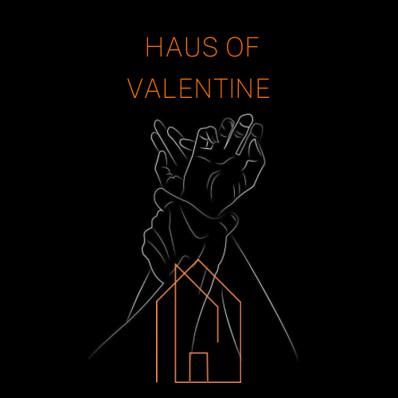
Liability Waiver Agreement – Haus of Valentine

- I have read, signed and understood that I am agreeing to adhere to the Terms & Conditions of hire for Haus of Valentine.

- I agree that I am consensually and voluntarily agreeing to partake in any activity at my own risk at Haus Of Valentine.

- I agree that I am at least 21 years old and understand that if I cannot prove this with identification, my session may be terminated, and I will not be reimbursed.

- I hereby take soul accountability and responsibility and acknowledge that there are inherent risks associated with participating in the activities offered at Haus Of Valentine and I accept those risks. I am aware that these risks may include physical and psychological harm, including but not limited to injury, pain, illness or death, emotional distress or the potential loss of income or other aspects of my life.

- I can confirm that the staff and contractors at Haus Of Valentine are not medical professionals, and I am not relying on them to provide medical assessments, diagnoses or treatment.

- I understand that it is my responsibility to ensure that I am physically and mentally fit to take part in all activities, and if I have any existing medical conditions, allergies, or am under the influence of drugs or alcohol, I will disclose before partaking.

- I acknowledge that Haus of Valentine does not accept responsibility for any losses, injuries, damage or death to myself that may occur as a result of my participation in the activities.

- I agree to follow all safety guidelines, instructions and rules provided by Haus Of Valentine and its staff.

- I understand that I am expected to respect the boundaries, consent and limits of all involved, and that any form of abuse, coercion or non-consensual behaviour is strictly prohibited and will result in immediate removal from the premises that may lead to legal action.

- I understand that if I am unsure regarding any aspects of the activities, or feel uncomfortable at any time, I will speak up and seek clarification from the Haus Of Valentine team. I also acknowledge that the participation in the activities is entirely my choice, and I am responsible for my own safety, well-being and decision making throughout my visit.

- By signing this waiver, I am confirming that I have read, understood and agree to the terms outlined above. I accept full responsibility for my actions, and I release Haus Of Valentine, its owners, staff and affiliates from any and all liability claims, demands or legal action arising from my participation in the activities, except in cases of gross negligence or intentional misconduct.

Name……………………………………………………………….…………………Signed……………………….…………………………..…….Date……………….…………………………………..

