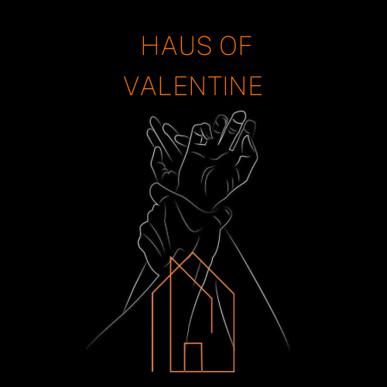
At Haus Of Valentine, we see our customers as valued friends. Our dungeon is a mixture of art, creativity and exploration. We want you to enjoy your time and return back to us. However, please take this time to read our Terms & Conditions of our expectations as your hosts…

BOOKINGS:
- There is nothing worse than feeling pressured for time, this is why we allow a 10 minute grace period either side of your booking FREE of charge. This is a courtesy for you and allows for setting up or packing down. However, after this window, you will be kindly urged to leave due to the session that may be in after you. This isn’t to be rude, this is purely for booking and hygiene reasons. We check the studio after every session and also do a deep clean of the room, equipment and any toys that have been used.
- Please see website for cancellation details.
COST:
- Our costs reflect the quality and quantity of equipment. We offer fare rates as we want you to keep coming back for more! However, over time this may change due to cost of living, but here at HOV we pride ourselves on affordable excitement for all to enjoy.
- Our booking slots for The Dungeon are a minimum of 2 hours for £120, with the additional option to add any extra hours for £40 per hour, after the initial 2 hour session.
- The Jungle Room is priced at £275 Monday-Thursday, and £325 Friday-Sunday.
- We require a 50% deposit to secure any bookings, with the remainder of the balance to be paid 48 hours before your arrival.
DAMAGE:
- As the nature of our business, we expect general wear and tear. However, we have spent a lot of time creating a beautiful safe space for your enjoyment, so a polite reminder that ANY damages will be charged to you at cost – so please be respectful and keep the room as you found it.
- We ask to be made aware of any damage at the earliest possible convenience.
- If you feel any of our furniture or equipment is damaged or not fit for purpose; please do not use and inform a member of the team.
CLEANLINESS:
- A deep clean will be completed after every session by us, and therefore we do not expect a spring clean. However, we do expect all areas to be wiped down, re-belted and buckled back into place after your session.
- If there are any spillages on the floor, please make us aware of these before you leave.
- When using any of our insertable items, please ensure you use a condom and dispose of these correctly in the bins provided.
- At HOV we clean and sterilise any used items. Our only ask is that you place any insertable/used toys into the clear bin provided.
- We will always provide cleaning solutions, our only expectation is that you leave the studio in the pristine state you hire it in. You expect it clean and ready to go when you hire it, and so does the booking after you.
RULES:
- To hire The Dungeon, you are required to be 21 +
- Smoking is prohibited in not only the studio, but the WHOLE building. We kindly ask that if you do smoke, you do this outside of the premises.
- Candles are prohibited in the entirety of the building – this is a MUST not an ask.
- Hot wax is prohibited in the studio as it sticks to the leather and is a pain, if not impossible to remove. If this is something you are wanting, please ensure that you bring your own plastic sheets/coverings as this will NOT be provided during your visit.
- Hard Sports (including faeces/urine) are NOT allowed on any furniture at all costs; this is due to the odour rather than preferences.
- Soliciting / illegal activity are not permitted on our premises. If we believe you are engaging in sexual services for a commercial purpose; or partaking in any other illegal activities, we have the right to terminate your session, and a refund will not be issued.
FURNITURE / EQUIPMENT:
- We kindly ask that you supply and use your own disposable plastic sheets/coverings, especially when experimenting with internal play or blood play. The towels provided are NOT a substitute for this, they are provided for before/after care and shower use only.
- High heels and buckles can tear and scar the leather, so please bare this in mind. The furniture is for human use only, no luggage/bags or any items other than bodies.
- Lipsticks are oil based and again, a pain to remove. We kindly ask that if you are writing on your Sub, you bare this in mind whilst on any of the leather or upholstered equipment.
- Doing ANY of these is considered misuse, and any damage WILL be charged to you in order to replace or renew.
- Whilst we carry out regular maintenance of the equipment, the use of any furniture, equipment, kit or accessories, are used entirely at your own risk.
DISCRETION:
- Discretion is important to us, and we kindly ask that you arrive dressed appropriately and NOT dressed down, as we do have neighbours and passers-by. Please ensure that you have all belongings/equipment needed, as once you are ‘dressed’, you will not be able to ‘nip back to the car’ in all your finery.
- The studio does have some soundproofing, however, is NOT soundproof. If sessions have the need for increased volume, we ask that this be booked for 6pm onwards, out of respect for our neighbours.
- Please do NOT disclose the location of the venue as yours, ours and other guests’ privacy is paramount. We are a discreet business and aim to keep a discreet footprint.
DRESSING ROOM:
- The dressing room is a personal touch we have added for that extra bit of excitement and luxury. The dressing room is to be used for exactly that, dressing up/down and for any other hair/makeup needs. This is NOT a part of the studio and shouldn’t be used for anything explicit.
- If you are expecting a Sub/guest and are using the dressing room, please ensure you have added this time in with your booking slot as we cannot accommodate out of these hours due to other bookings around your session.
- Feel free to use the toiletries on hand, however, we kindly ask that you do not take them with you. We check stock daily, however, can’t accommodate 7 deodorant cans and 13 packs of wipes in a day!

Polite reminder, that if you can’t adhere to our Terms & Conditions, you will not be allowed to book a session here again. If you have any queries or would like more information, please email: info@hausofvalentine.co.uk or DM us on WhatsApp.

Now the boring stuff is over, strip off, relax, and we hope you enjoy this unique experience at the Haus Of Valentine.

Lots of love,
HOV Team.

Name………………………………………………………………………………Signed………………………………………………..…….Date………………………………………………..

..

